REPORT ON ONE DAY MULTIDISPALINARY
NATIONAL SEMINAR
‘SUSTAINABLE DEVELOPMENT: GOALS & CHALLENGES’
on
17th FEBURURY 2024
Department of Commerce, Government College, Bawal, Distt. Rewari – Haryana (INDIA) organized a one – day national seminar on “Sustainable Development: Goals & Challenges” with the permission of Director General, Higher Education, Haryana vide letter No. K.W.U. 170008/7- 2023 N.P.E. (2) Dated 09/02/2024 on condition of without financial assistant. However, it was very challenging to organized National Level Seminar without financial assistant, but whole G.C. Bawal family accepted this challenge and under the supervision of Smt. Archna Soota, Principal, with cooperation of all the staff members (teaching & non-teaching), Dr. Joginder Singh, Convener and Sh. Santpal Co- convener of the seminar managed it successfully.Organizer collected a sum of Rs. 92200 as fee from the participants and remaining expenditure amount Rs.53300 borne by the college. In this seminar, 141 papers were submitted by 200 participants.Among them 10 were out of states- Rajasthan, Delhi, Chandigarh, Punjab and U.K. In this seminar 154 faculty members and 46 research scholars of various universities participated. In 154 faculty members, 88 were women and 66 men, likewise in 46 research scholars 32women and remaining 14 were men participated.
Inaugural Session
Inaugural Sessionstarted at 10.00 a.m. with the lamp lightening ceremony by the Chief Guest Prof. Suresh Kumar Sharma, Retired, Director of Regional Centre at Rewari, M.D. University, Rohtak,nowadays is Indira Gandhi University, Meerpur, Rewari (Haryana).Smt. Archana Soota, Principal, Government College, Bawal welcome all the guests and participants.
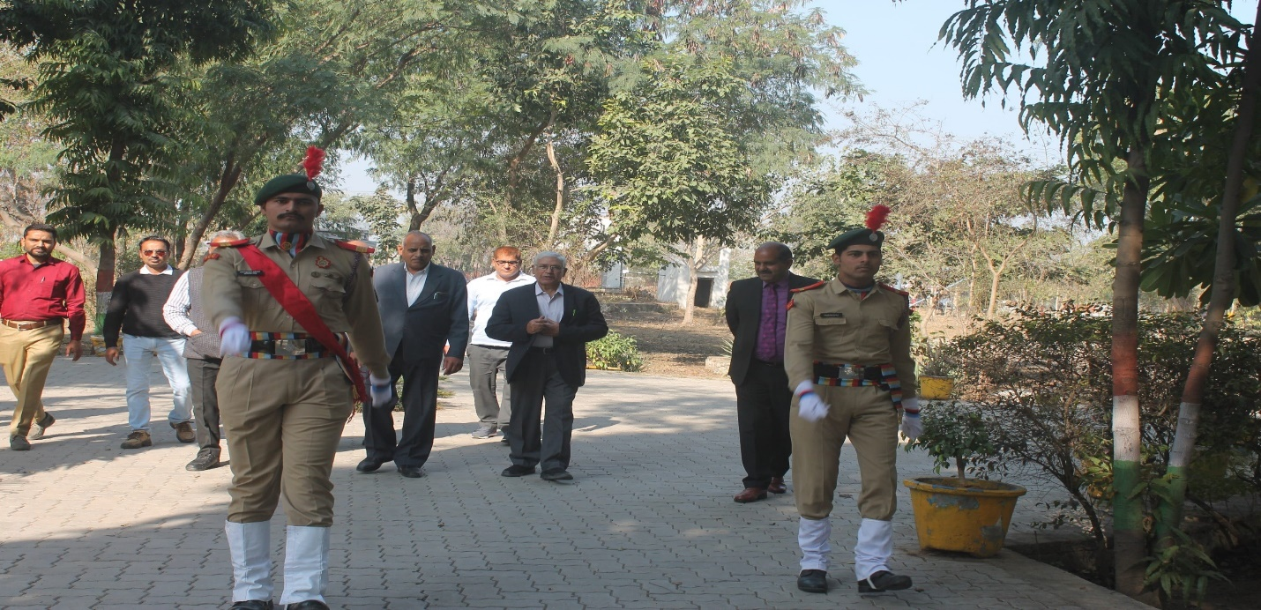
Chief Guest escorted by the NCC Volunteers
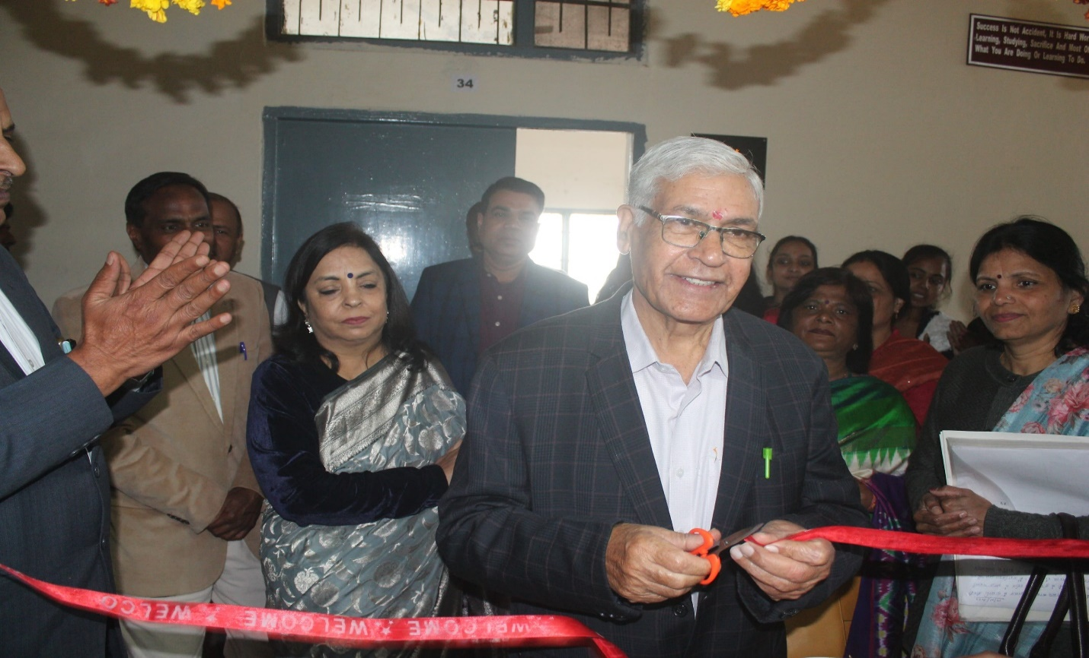
Prof. S. K. Sharma, Chief Guest, Inaugurating One Day Multidisciplinary National Seminar

Opening remarks and introduction of the seminar was given by Dr. Joginder Singh assistant professor in commerce. He highlighted seventeen goals and their targets to achieve for sustainable development. He mentioned about the challenges faced by the country the same and emphasized the need of sustainable development.
Dr. S. K. Sharma, Chief Guest emphases on SDG particularly on SDG - 4. It Ensure inclusive and equitable quality education and promote lifelong learning opportunities for all. He also added that National Education Policy (NEP)-2020 will play a vital role in this goal.Education for sustainable development (ESD) gives learners of all ages the knowledge, skills, values and agency to address interconnected global challenges including climate change, loss of biodiversity, unsustainable use of resources, and inequality.
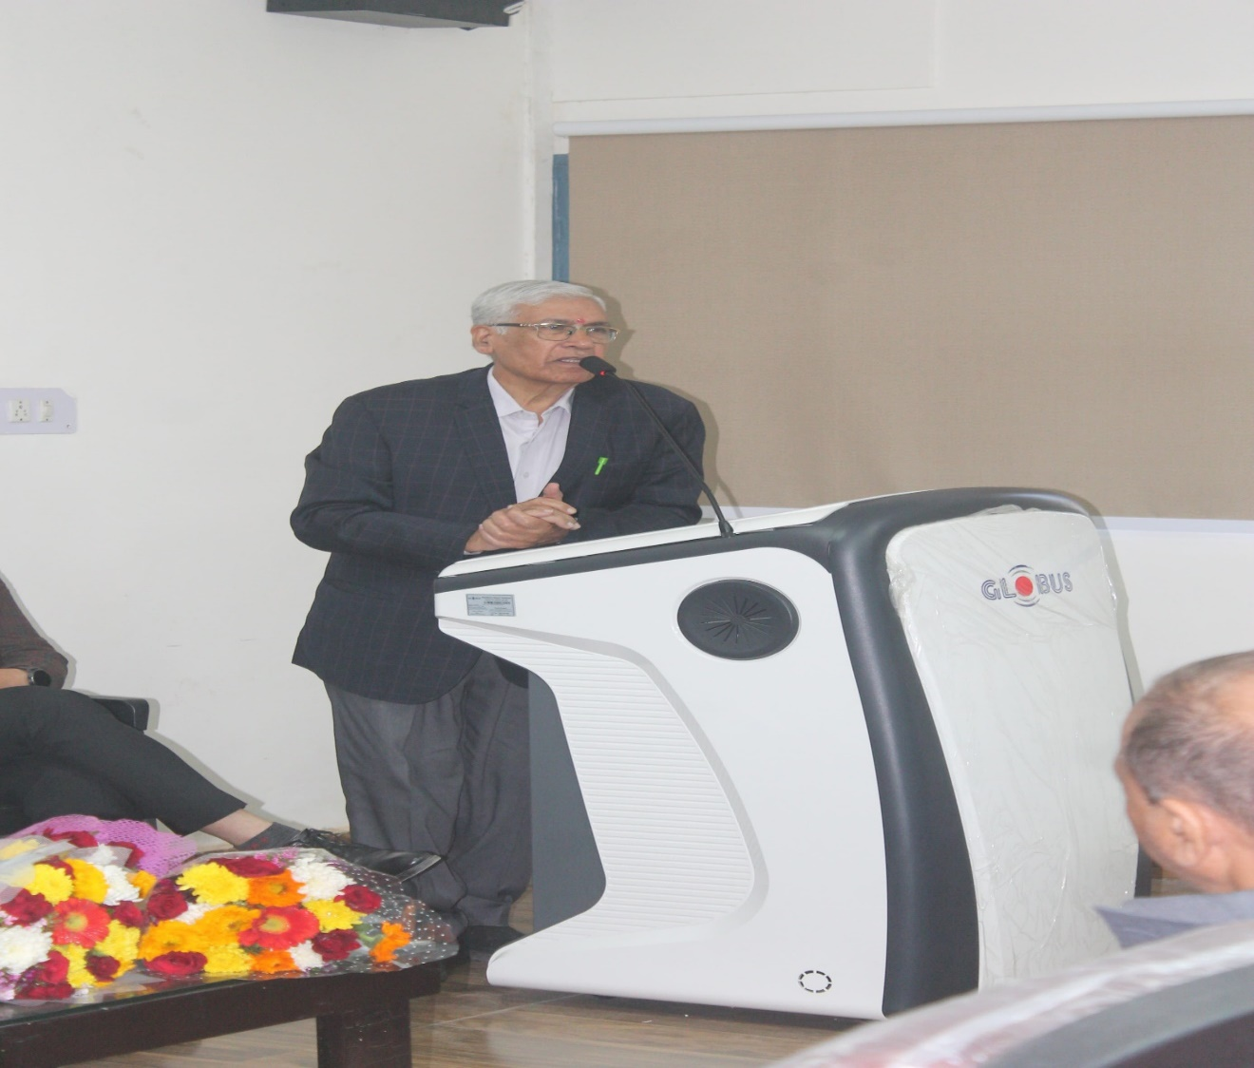
Dr. S. K. Sharma, The Chief Guest addressing the stakeholders
Dr. Ramniwas, The Resident Medical Officer Civil Hospital,Bawal was The Guest of Honor in the seminar. In his speech he pointed out Sustainable Development Goal-3 (SDG-3). He said that SDG 3 aims to prevent needless suffering from preventable diseases and premature death by focusing on key targets that boost the health of a country's overallpopulation.
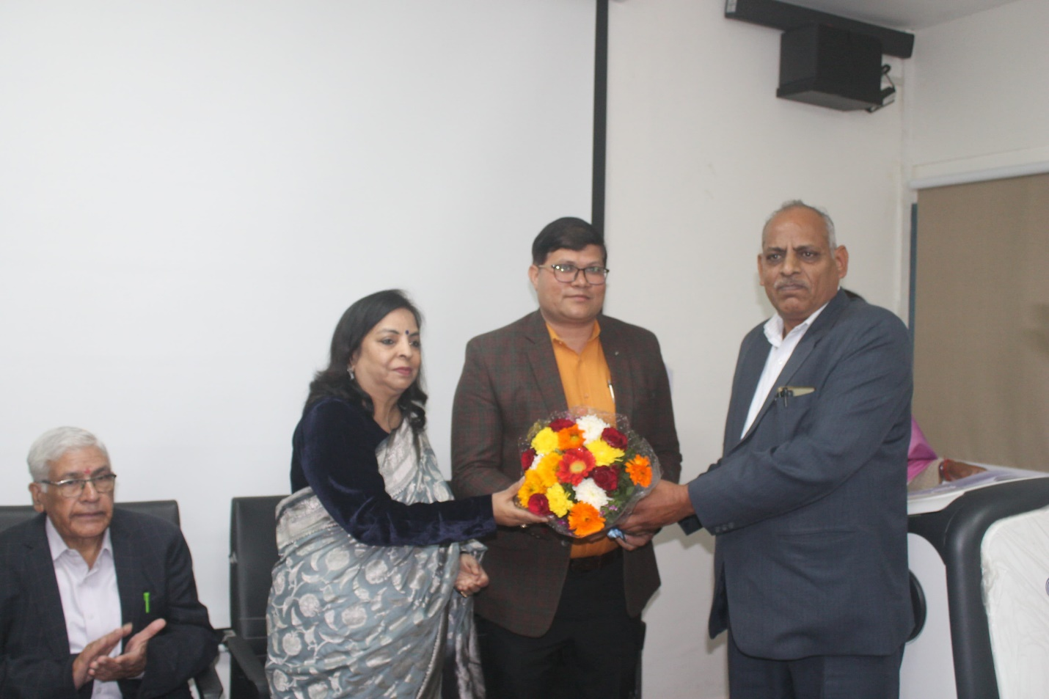
Dr. Ramniwas, Resident Medical Officer, welcomed by the Principal and Convener
Prof. Tej Singh, Dean, Faculty of Management & Commerce, IGU, Meerpur, Rewari as a key note speaker shared his knowledge regarding all the seventeen Sustainable Development Goals, with parameters, targets etc. He gave a Power Point Presentation in the seminar.
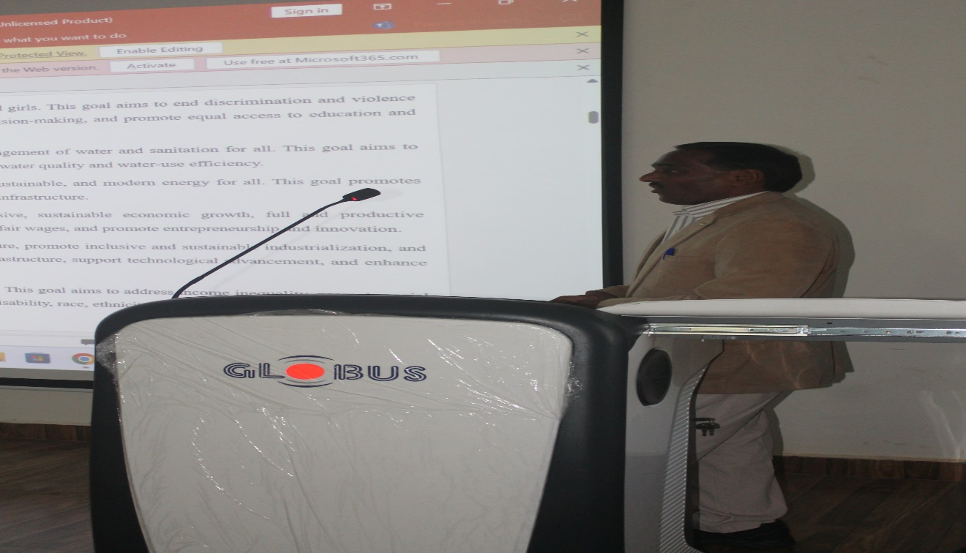
Prof. Tej Singh The Key note Speaker’s presentation in Seminar
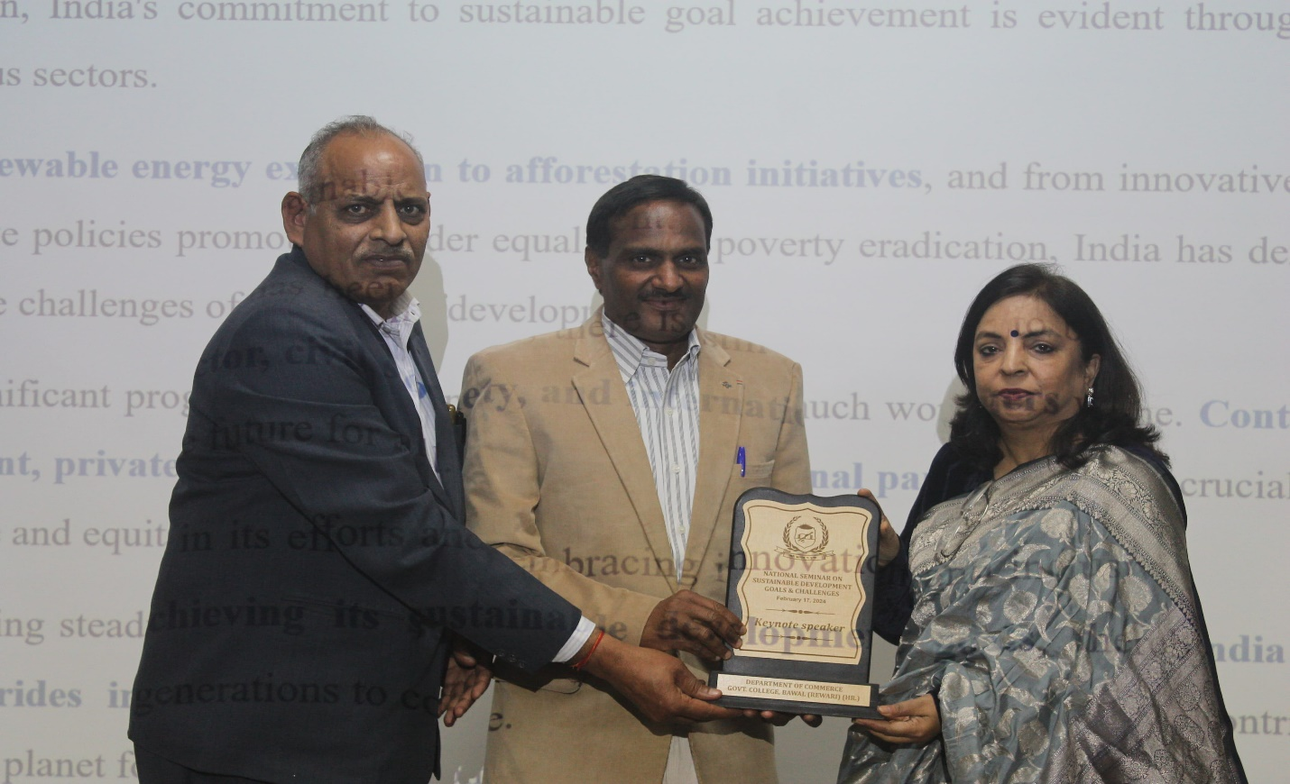
Honoring the keynote speaker
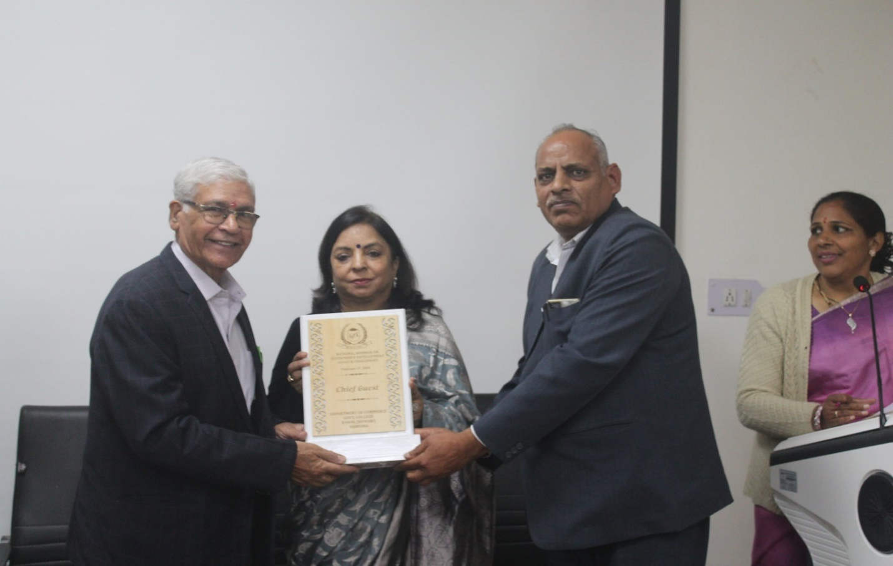
Bestowing with Memento to the Chief Guest
Technical Session -I
After honoring the Chief Guest; Guest of Honor;Special Guest, Key note Speaker and tea break technical sessions started.
Track -1 (A):Dr. Dalbir Singh, Principal RDS College, Rewari and Dr. Ishwar Sharma Assistant Professor Commerce, IGU Meerpurwere resource person and chairperson respectively for this technical session, held in seminar hall. Dr. Kiran Sharma, G.C. Bawalconducted the stage and Sh. Devender Sharma was technical assistant in this programme. In this track twenty papers of thirty-one participants were considered. Here, it should be noted that sixteen faculty members and fifteen research scholars presented their paper.
Track -I (B):Dr. Vijay Singh, Associate Professor in Govt. College Matanhel(Jhajjar)and Dr. Abhay SinghAssociate Professor K.L.P.College Rewariparticipated as resource and chairperson respectively for this technical session held in Computer Lab-II. Smt. Savitri Devi performed her duty as stage in- charge and Sh. Devender Kumar Computer Instructor was technical assistant ofthis venue. In this track also twenty papers were considered from thirty participants consisting twenty faculty members and ten research scholars.
Special Track for on-the-spot registered participants:Keeping in mind, the huge number of on-the-spot registration, convener have already prepared plan (B) and provided a new venue for them i.e. Room No. -16. Sh. Anil Kumar (Finance Office, IGU, Meerpur) and Sh. Manoj Kumar(Deputy Director (Retd.) Department of Social Welfare, Haryana)voluntarily bearded responsibility as resource person and chairperson respectively.Smt. Sudesh Devi was stage in-charge of this venue. Due to large numbers of presenters’ chairperson allowed only selected authors of papers. So, forty-one papers were included out of fifty-four participants, without lunch break this session was continued till 3.30 p.m. Convener and organizing committeepaid voteof thanks to resource person; chairperson; stage in-charge and participants of this programme.
Technical Session -II
After lunch break evening session started at 2.30 pm.
Track -II (A):Dr. Anand Prakash (Assistant Professor in Computer Science, GC Rewari) and Sh. Manish Kumar, Assistant Professor of Geography Govt. College Akbarpur-Bissar (Nuh) were resource and chairperson respectively for this technical session. Twenty papers of thirty-one participants were allotted. There were twenty-four faculty members while seven were research scholars.
Track -II (B): Prof. Sanjeev Kumar(Raffles University, Neemrana) was resource person and Dr. Sunil Kumar(Associate Professor Govt. Girls College Sector-18 Rewari)was chairperson.Forty-one papers of fifty-four participants were assigned to this track. Due to shortage of time resource person & chairperson decided to give a chance of presentation to some selected papers.
Valedictory Session
After technical sessions, valedictory Session started. In this session our Chief Guest was Prof. J.S.Yadav (Dean, School of Agriculture sciences) K.R. Mangalam University, Sohna (Gurugram). Smt. Archana Soota, Chairperson & Dr. Joginder Singh, Convener welcomed the chief guest.In this session first of all chief guest addressed the participants and welcomed the resource persons & chair persons of the seminar. He also awarded certificates to the paper presenters and participating faculty members & research scholars. The seminar was ended by giving a vote of thanks by Sh. Santpal organizing sectary of the seminar.
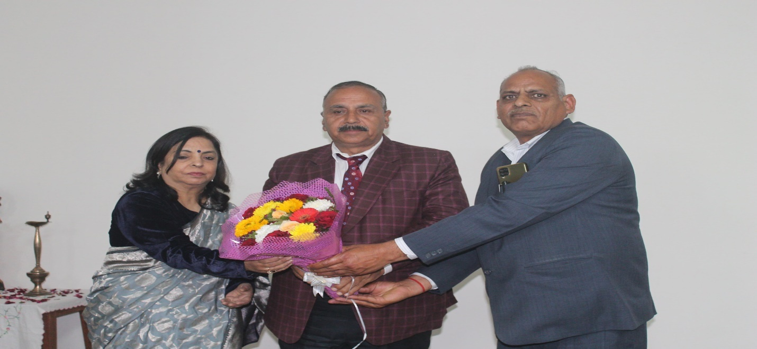
Prof. J.S. Yadav the Chief guest welcomed by the Principal & Convener
In this session first of all chief guest address the participants andthen hebestowing with Memento to the resource persons andchair persons of the seminar. He also awarded certificates to the participating faculty members and research scholars.
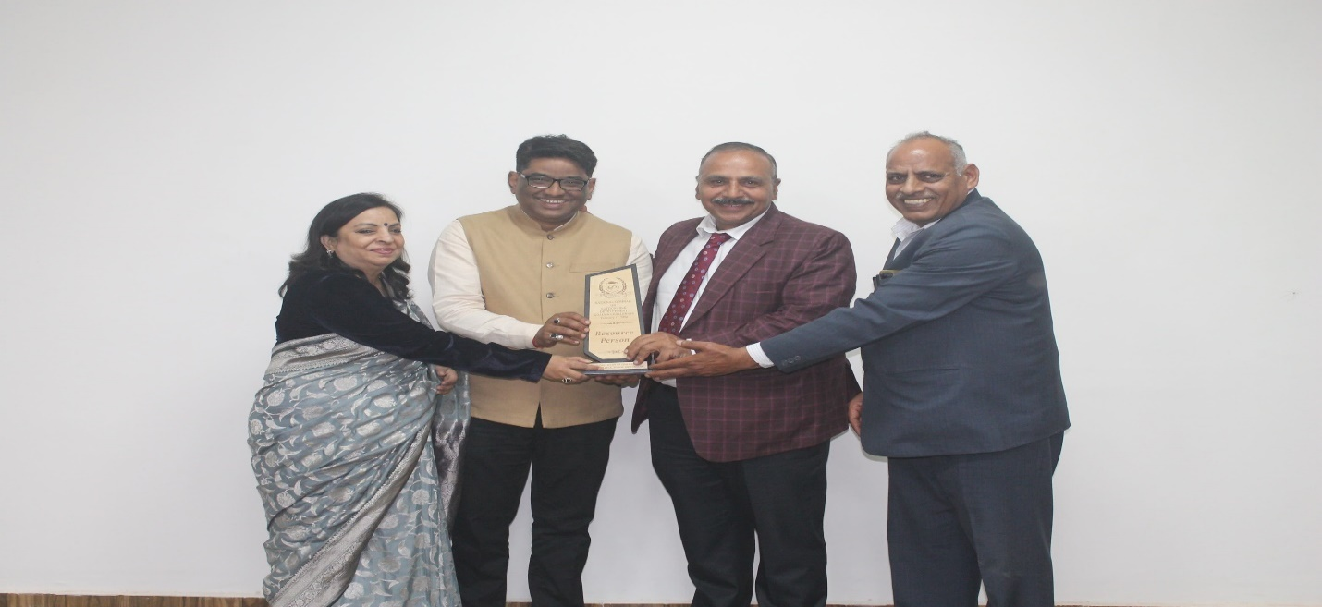
Prof. Sanjeev Kumarreceiving a token of honor from the Chief Guest
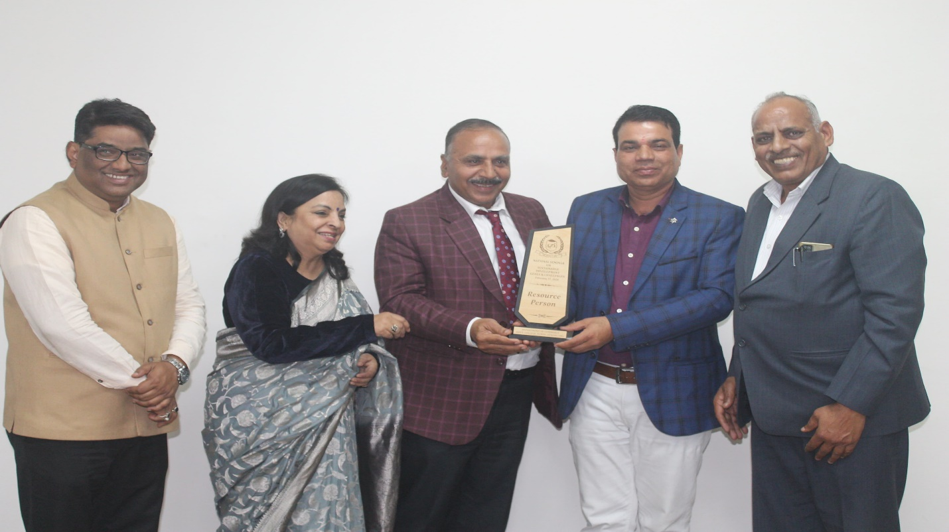
Dr. Anand Parkash bestowed with a memento
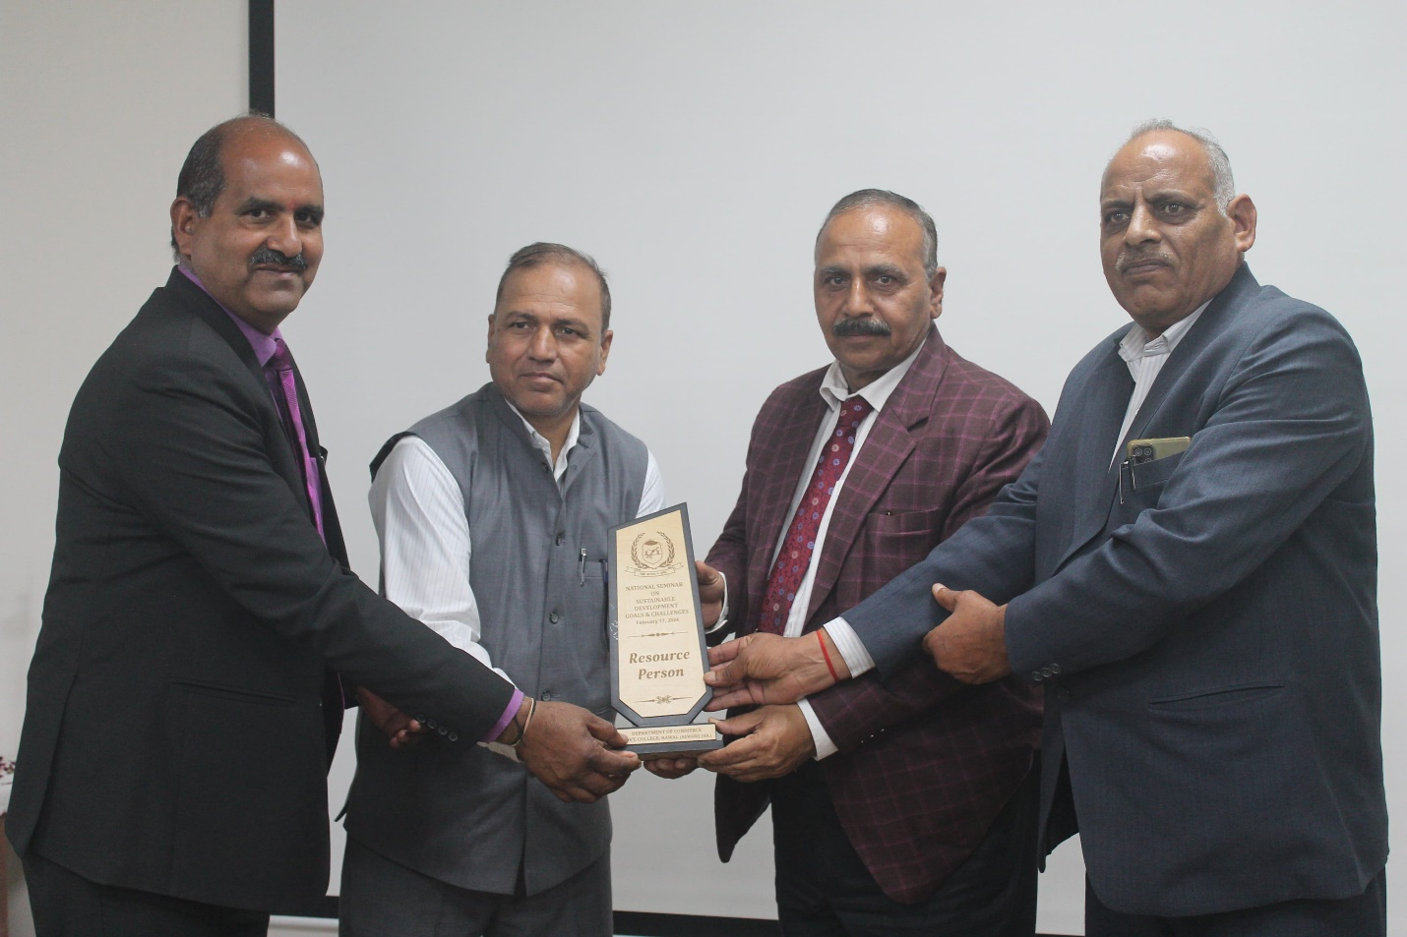
Dr. Vijay Singhbestowed with a memento
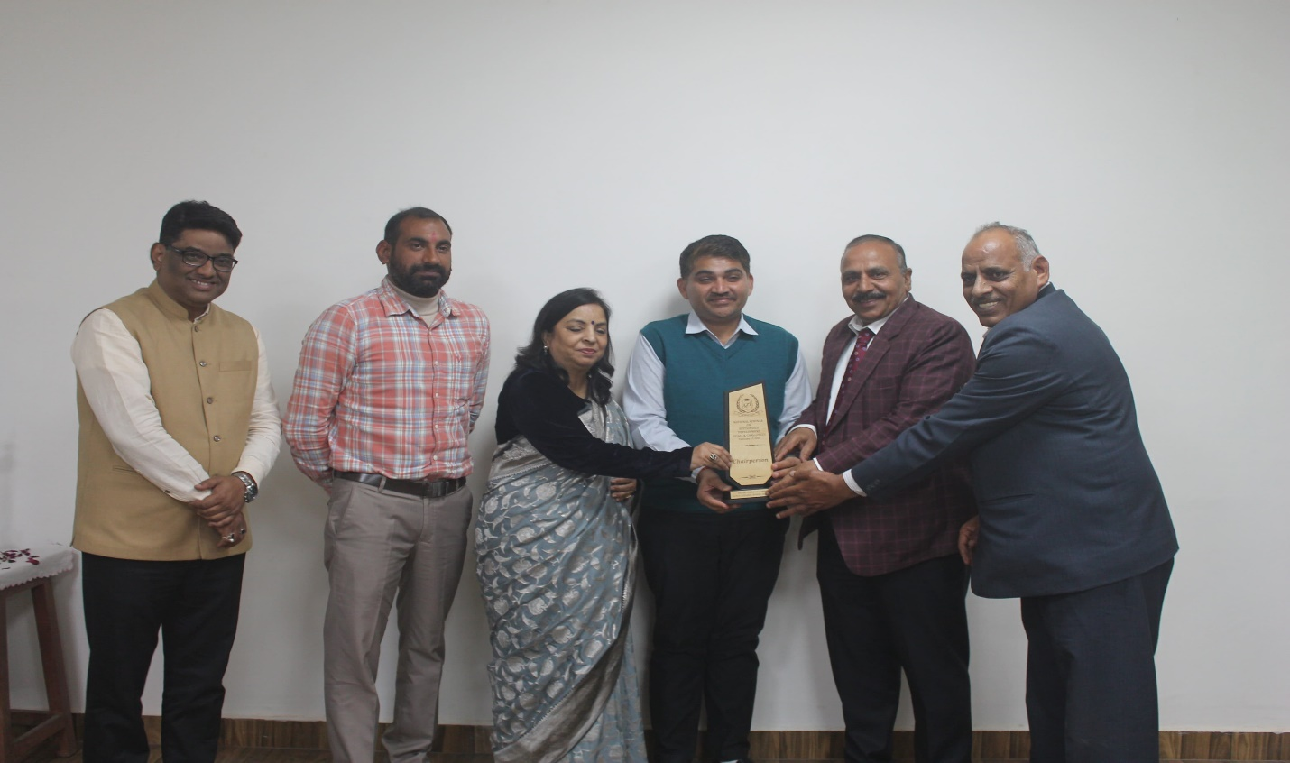
Dr. Sunil Kumar bestowed with a memento
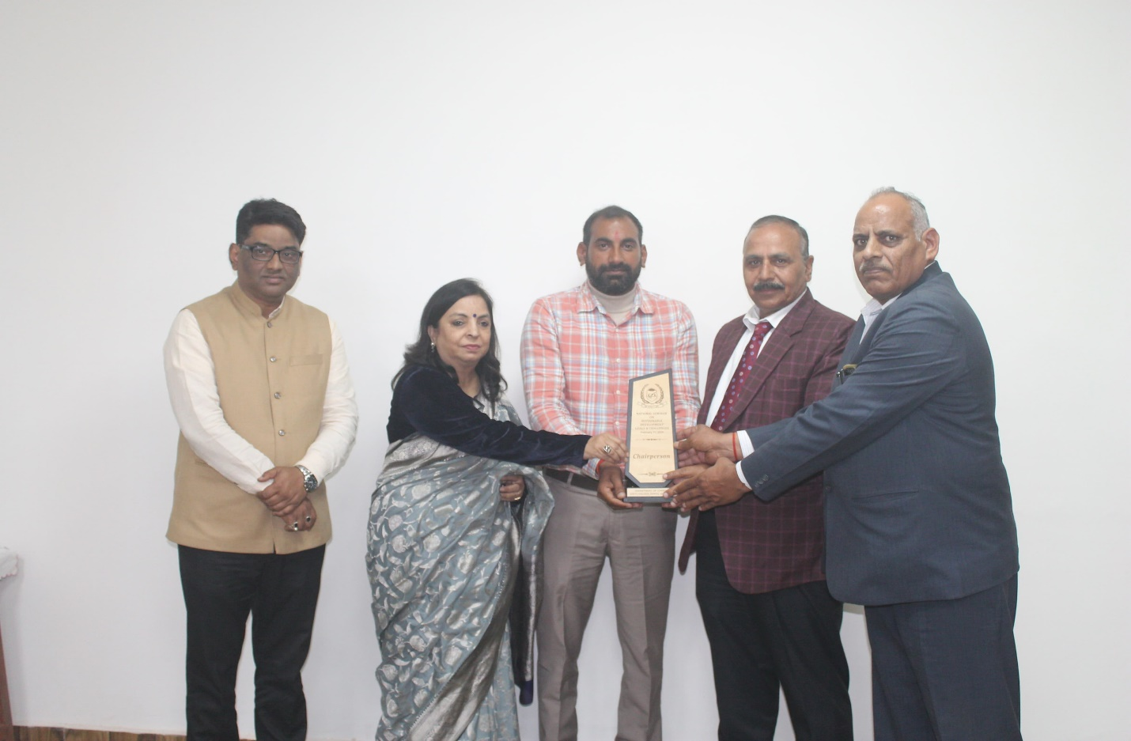
Sh. Manish Kumarbestowed with a memento
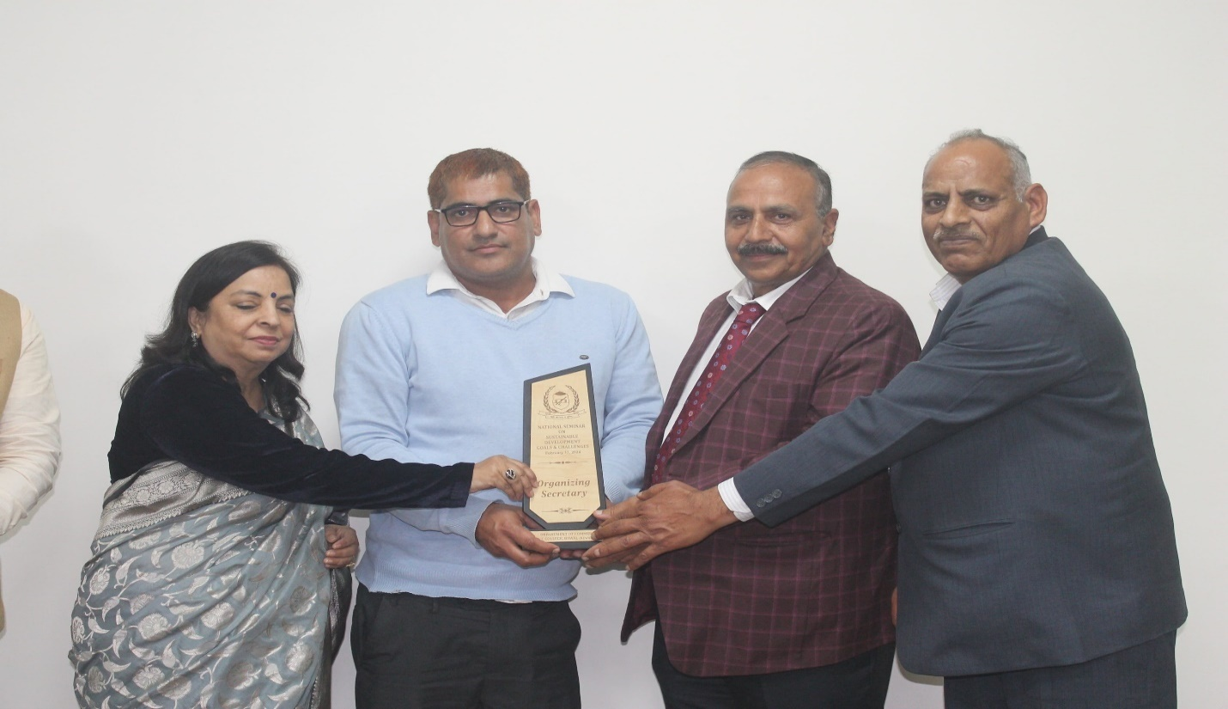
Sh. Santpal ji (Organizing secretary) bestowed with a memento by the Chief Guest
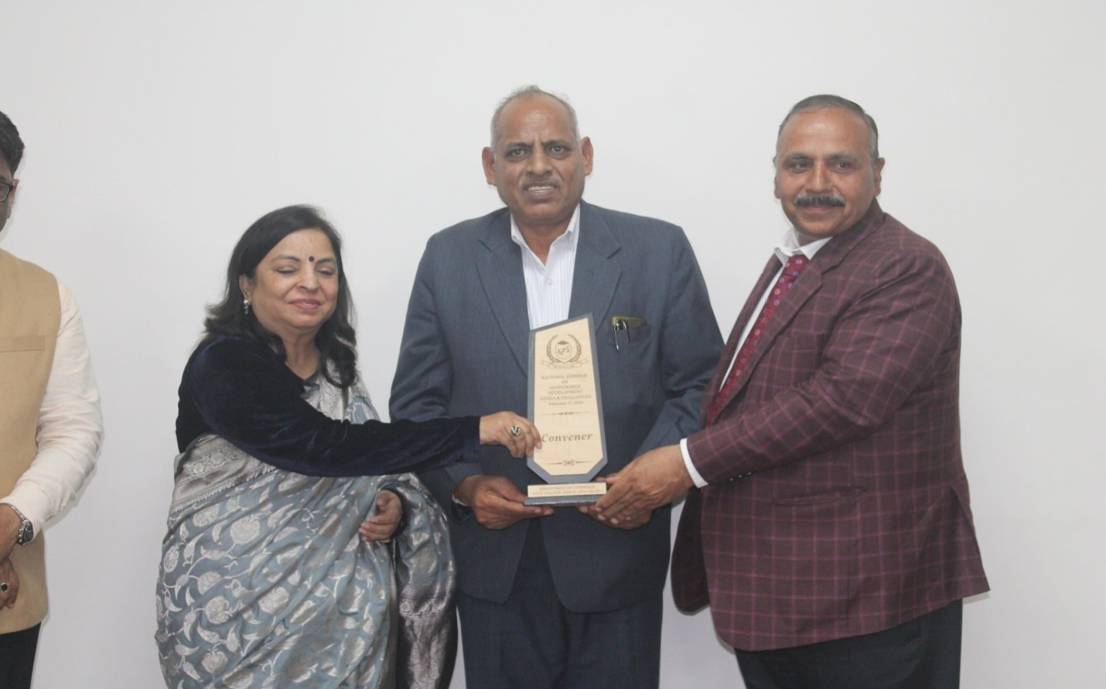
Dr. Joginder Singh, (Convener)bestowed with a memento by the Chief Guest

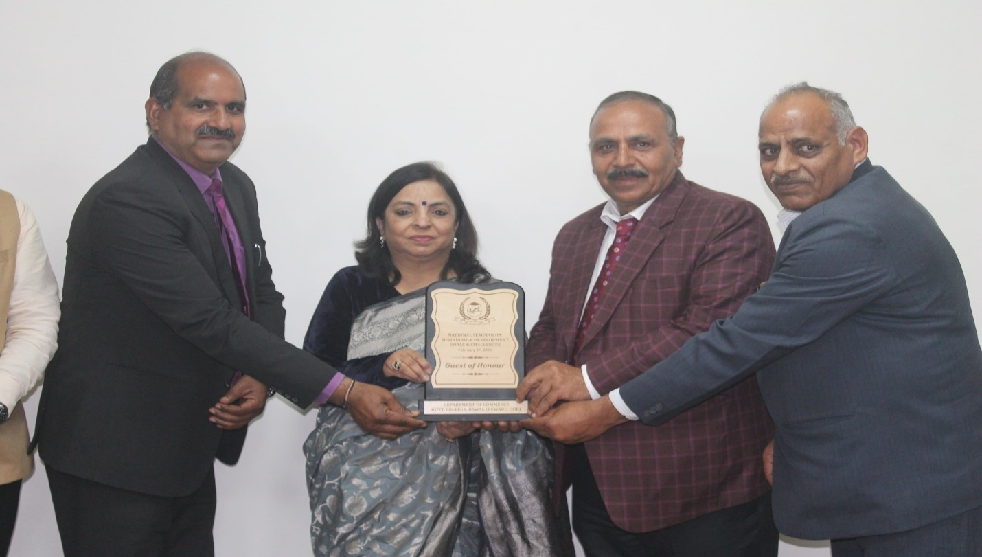
Smt. Archana Soota (Principal)bestowed with a memento by the Chief Guest
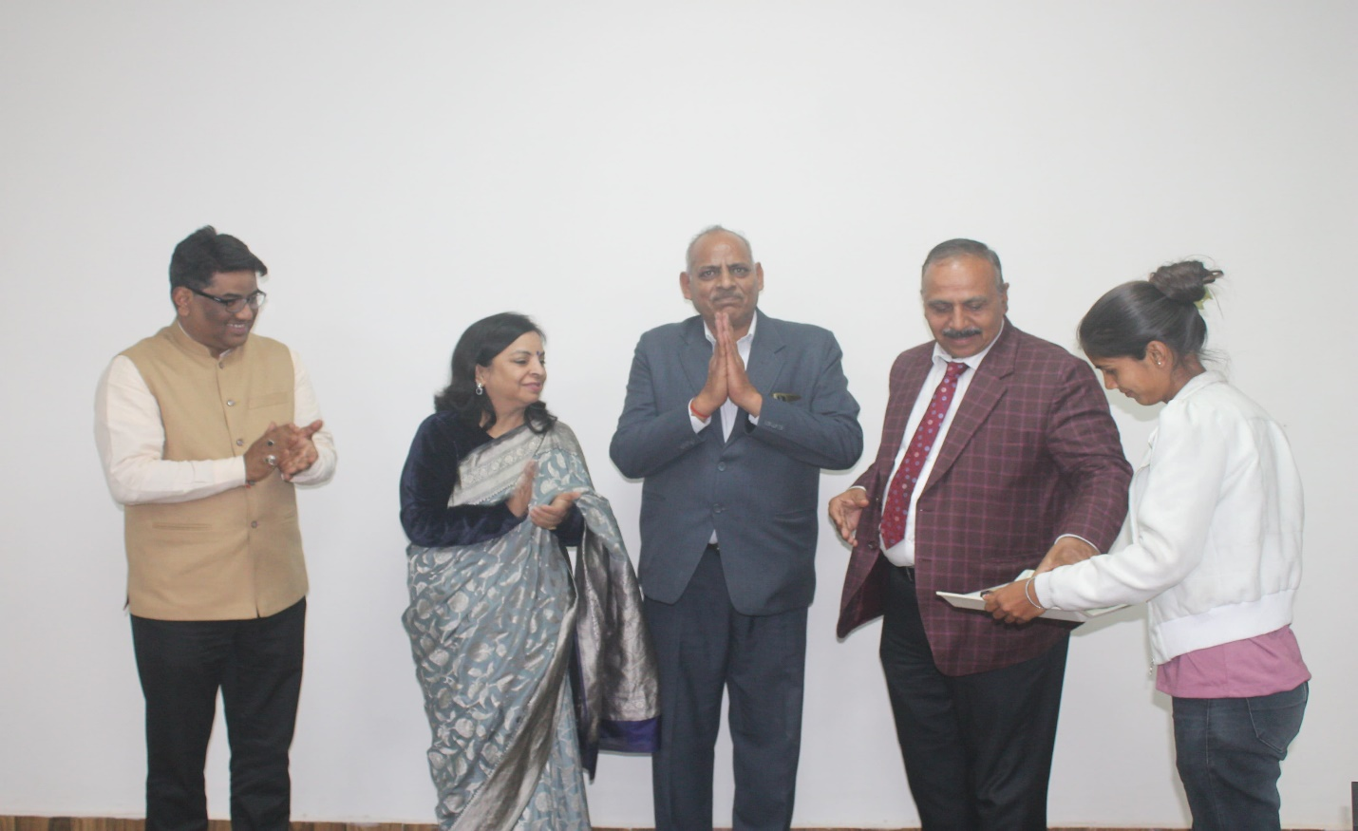
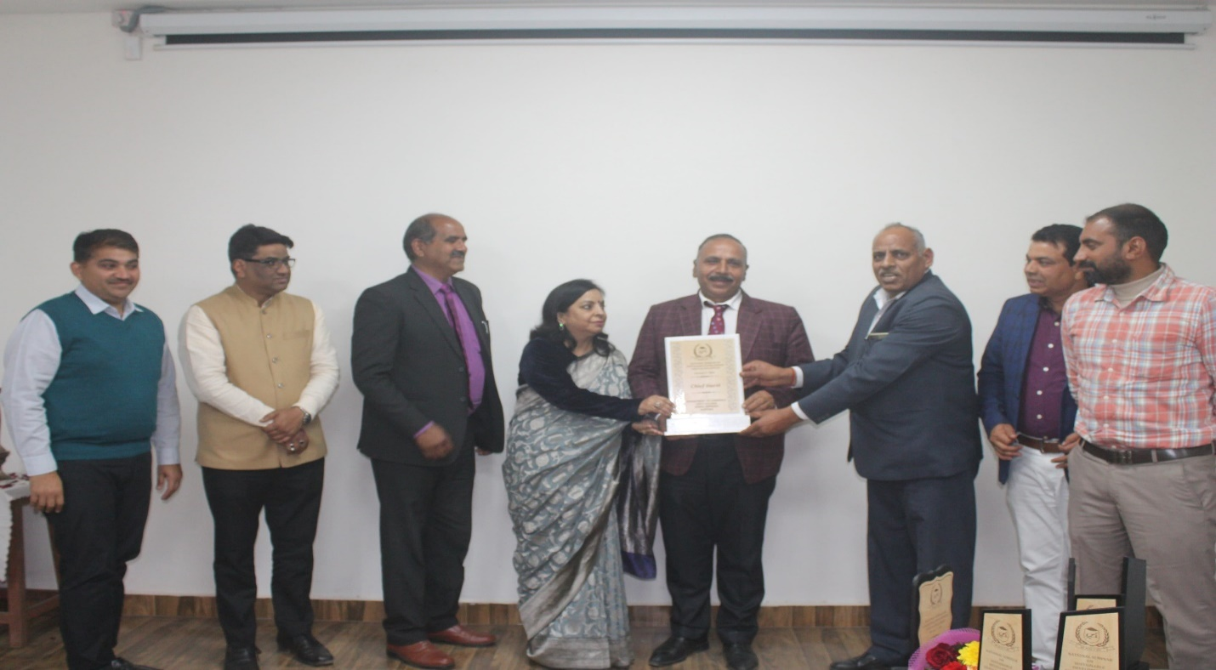
Principal, Convener, Resource Persons and Chair Persons Honoring the Chief Guest, Prof. J.S. Yadav with memento
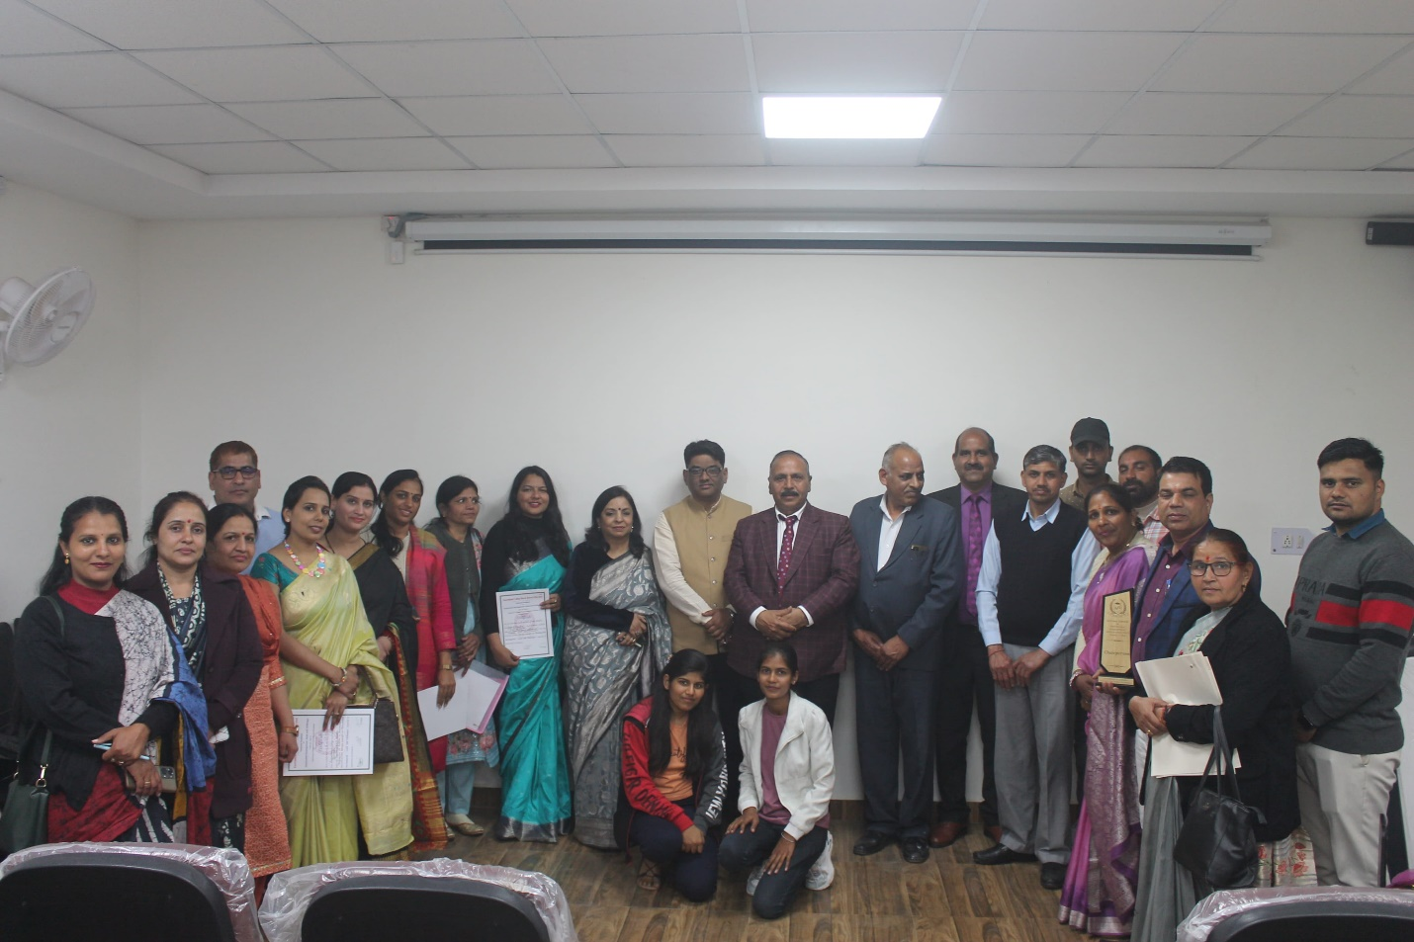
Group photo with the Chief Guest
